Registration: very detailed instructions

This guide will show you how to register and set up your online project on ProjectBoard. If need help, please email prsfair2020@gmail.com

Step 1 – Get started

Go to hhttps://mystemspace.ca/create-account/

This will take you to mystemspace.ca where you will see a sign-up box like this:
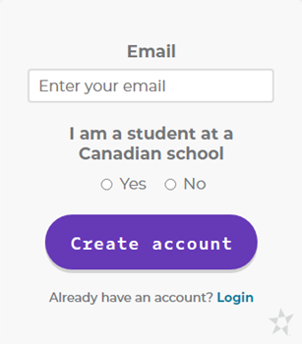

Enter your email address, check YES, and click Create Account. Each participant must have a unique email address.

Step 2 – Portal registration

You will then receive an email from Youth Science Canada with a link to set your password. When you click on this link you see the following box:
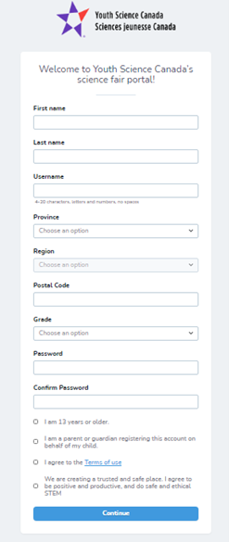
Enter student information in this box. Select the Peterborough Region

There are 4 check boxes at the bottom of the form:

- If you are a student 13 years or older, you will check off the 1st, 3rd, and 4th boxes.
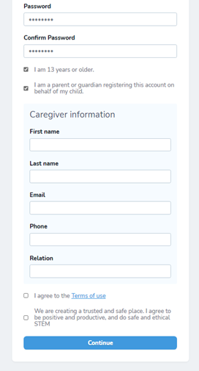
- If you are a parent/guardian/teacher you would check of all 4 boxes. When you check off the 2nd box, another section of the form appears to enter the parent/guardian teacher information, as shown here

Once all info is entered
Click CONTINUE.

Step 3 – Bookmark the portal
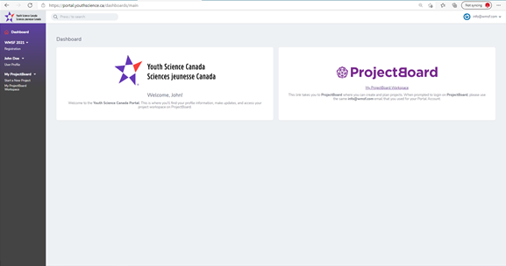
You should now be in your YSC portal! Your screen will look like this:

This is the place you will come back to when you want to continue working on your project and register for PRSF. It would be a good idea to bookmark the address https://portal.youthscience.ca so you can easily come back and log in with your email and password that you created.
Step 4 – Log in to ProjectBoard for the first time
In the ProjectBoard square on the right, click on the link the says My ProjectBoard Workspace. This will take you to the Project Board website.
Click on the red box in the top right corner of the page.
Enter your same email address you used to register for the portal (this is IMPORTANT). Click Next. You will receive an email from Youth Science Canada with a verification code. If you don’t receive the email within a few minutes make sure you check your spam/junk folders. Once you receive the verification code, enter it into the box and click CONTINUE.
Step 5 – Set up your project in ProjectBoard
**Please note that if you are doing a Group Project, only ONE of you will set up the project in ProjectBoard, and then you will invite the other person. Specific instructions on how to do that are in Step 7. **
You are now in your personal ProjectBoard space! This is where your online project will be created, developed, and displayed.
To get started on your project, click on in the top right corner.
Choose the English or French template and click NEXT. Read through the safety and ethics check items and click OK.
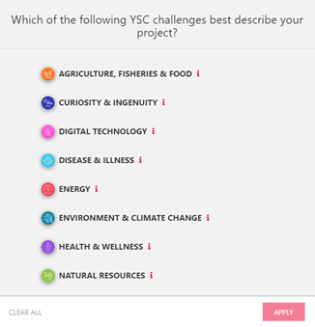
Next, the following screen will pop up, where you will choose the Challenge that best describes your project:
We don’t use these Challenges for PRSF, however this step is built into the projectboard system, so just choose the Challenge that best describes your project. If you hover over the red i beside each challenge it will give you a description. Choose Curiosity & Ingenuity if your project doesn’t fit into any of the other Challenge categories. Click Apply.

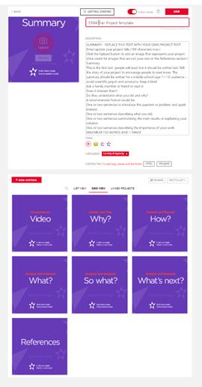
Now you are in your project space. Here you can update your project title and description, and then work your way through the purple section of the template. When you click on one of the purple sections, there will be instructions and/or suggestions of how to use that section.
You can save your changes by clicking on the red Save button and come back later to continue working on your project.
IMPORTANT: set to 'Public Mode'.

PLEASE NOTE: In the video section of the template you will see it says a maximum of 1 minute. Please disregard this; you may upload 4 minutes or less video.

Step 7 – For Group Project only – Inviting your partner
Both partners must have created their own individual YSC portal accounts first, with two different email addresses (see Steps 1 to 3). Then one partner starts a project on ProjectBoard (see steps 4 and 5).
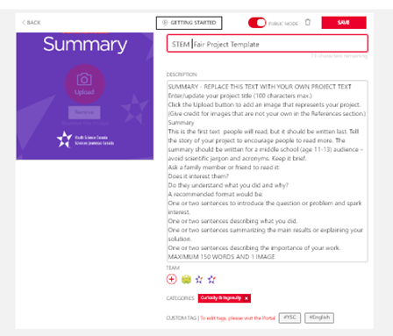
Once you have a project started, click on the + under the project description as shown here:
Click on ‘Add another row’
Type in the email address of your partner (that they used to sign up for the YSC Portal). From the down menu, be sure to choose ‘Co-Owner’.
Your partner will now be able to see and edit the project when they login to Project Board from their YSC portal.

