HELPFUL TIPS

Registration
- you have to select your region – select Peterborough

- Remember to press submit in each section - it will turn green after completed

- If your child is under 13 and you fill in the parent information, check the I am over 13 box

- School Information: Type the first couple letters of your school, a pull-down menu should appear, click on your school. The school information below will automatically fill in. If the school doesn’t come up email: prsfair2020@gmail.com and tell me the school name and I will add it.

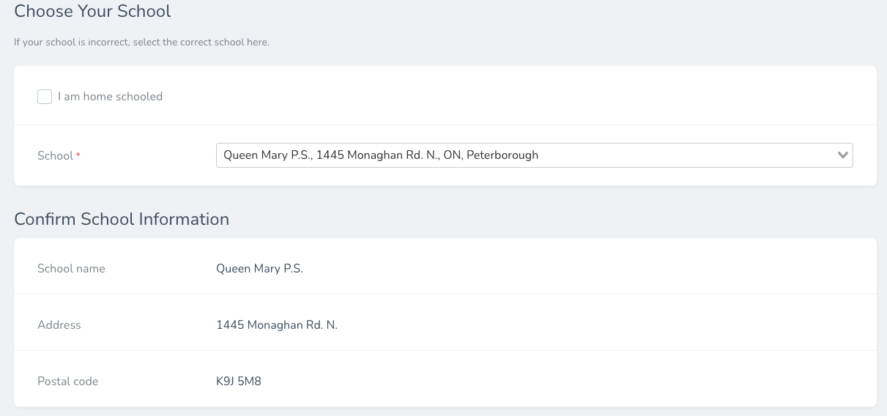

- In the PROJECTS section you have to link your registration to your project on ProjectBoard – make sure you click on the dot under “select” it will turn blue. Then hit the link icon and it will take you to your project on ProjectBoard

- Under Project Information you will be asked to select Discovery or Innovation
Our website list four project types: Innovation, Experiment, Demonstration and Study. If you have the latter three select: Discovery

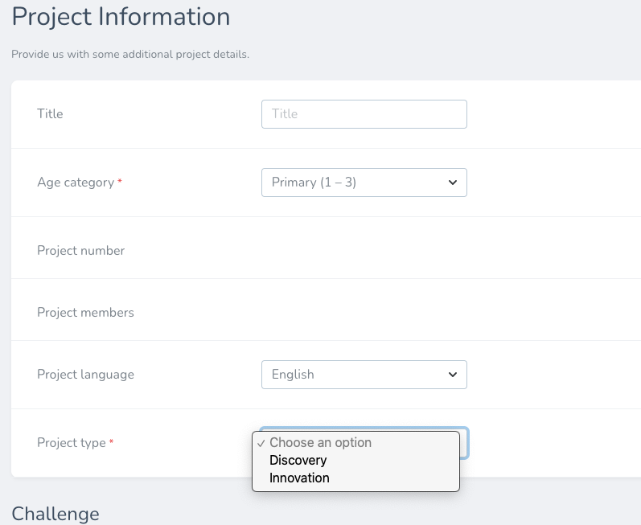

- You must go to Additional Information Page, download and print the signature page and fill out the safety questionnaire. If you cannot download the signature page email:
Prsfair2020@gmail.com and I will email them to you

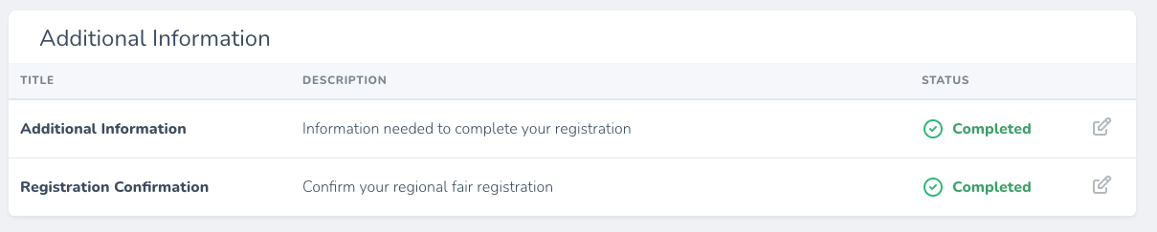

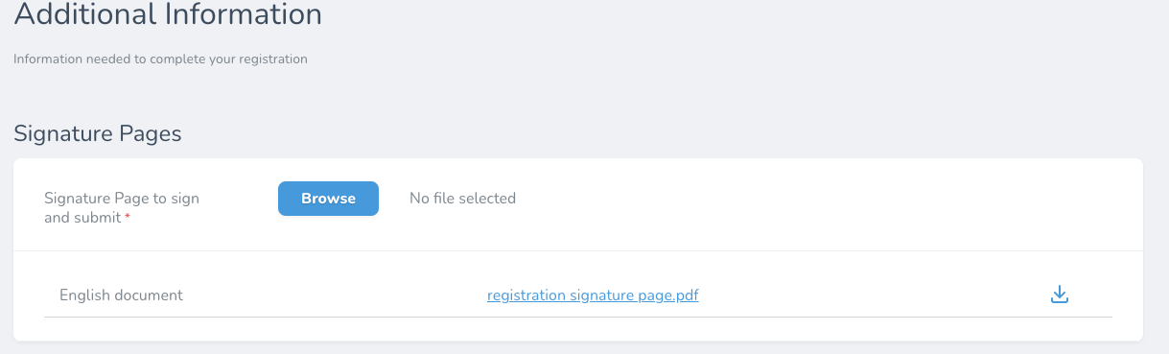

ProjectBoard Helpful Tips
- Toggle from private mode to public (see green circle below)
- click on any purple box you want to work on
- To add information: on the top right of the purple box there is a pencil icon with the word edit, click that
- the text box will come up will all the instructions on what to enter in that box. To add your information you have to delete that text so if you think you might want to read it again, cut and paste into a word document OR this link has an abbreviated version
- add: video (it says 1 minute on the template but it may be up to 4 minutes
- add: pictures, graphs into the different boxes to do this: under the purple box there is a long line of boxes with + symbols in them (see picture below). You click on that and then icons appear for the different options. The drag and drop works well if you don’t want to select a file. There are limits to the number of upload items so make sure you read the instructions. You can see in one box I have loaded a picture of butterflies

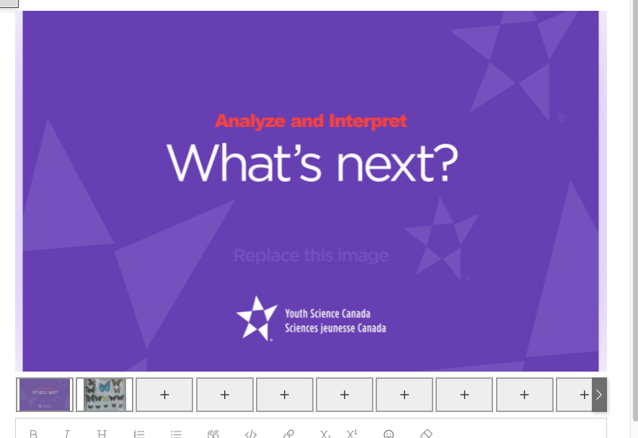

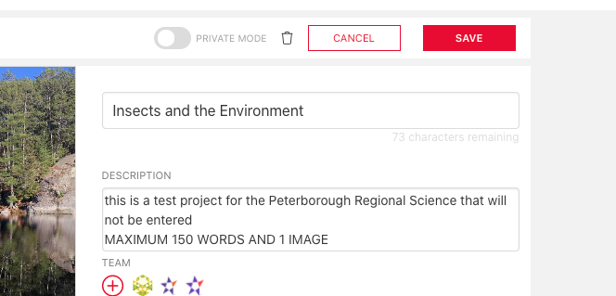

- Remember to save – see picture above – red box
- References are not required for Primary and Elementary
- You don’t have to use up your word count especially for primary projects
- Your video length can be between one and FOUR minutes

Share your project with a teacher/parent/guardian

- That person must go to: https://projectboard.world/ysc
- Click > START - purple rectangle button (top right)
- Enter an email address
- Select > I want to view projects

The student who created the project must do the following to share it:

- To the left of the red square edit button, toggle to public (this does NOT make it public on the internet)

- There is a red, round button with a + in it > click it
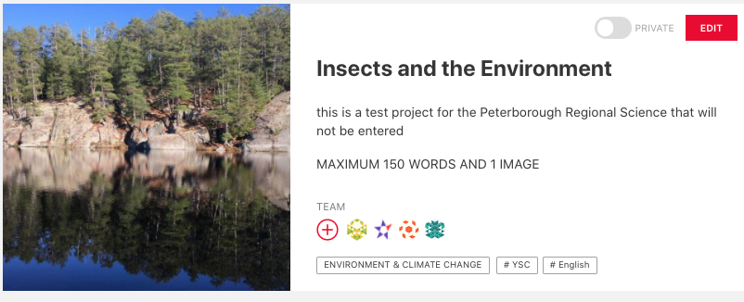

- The screen below comes up, click on the red circle with a + sign “add another row”
- In the blank line > add the email that you want to share the project – it MUST the same email the person used to sign-up to view projects

- In the pull-down menu switch Co-owner to view only or contributor (a contributor can write comments, but they cannot delete any information)

- Bottom right click> red square save

